USER MANUAL FOR

“Appointment Scheduler for Sample Collection” APPLICATION.

After Starting server the local-host address is as below,

<https://datasciritwik-live-project-2022-app2-izvaer.streamlitapp.com/>

This is the welcome screen for “Appointment Scheduler for Sample Collection”.

Image-1: It showing in detailed about Co-ordinates which are taken in Database for Calculating Distance as respect to Time.

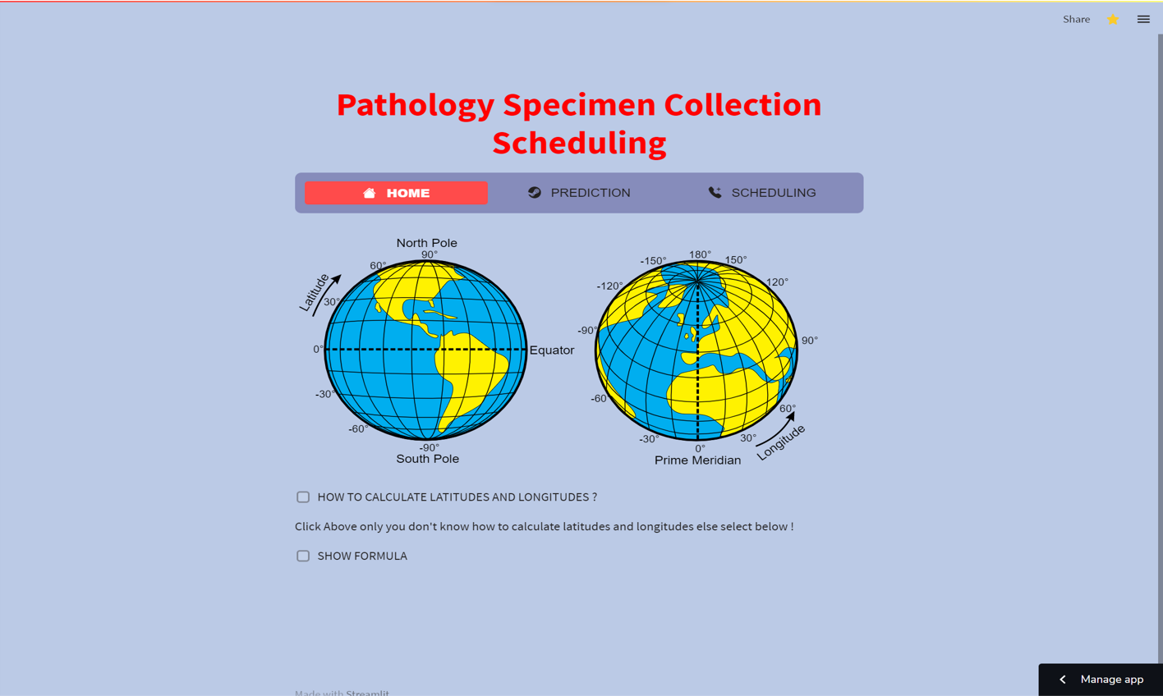

Image 2:- This is the Main UI page which is mandatory fields for user-end to enter/choose values for prediction.

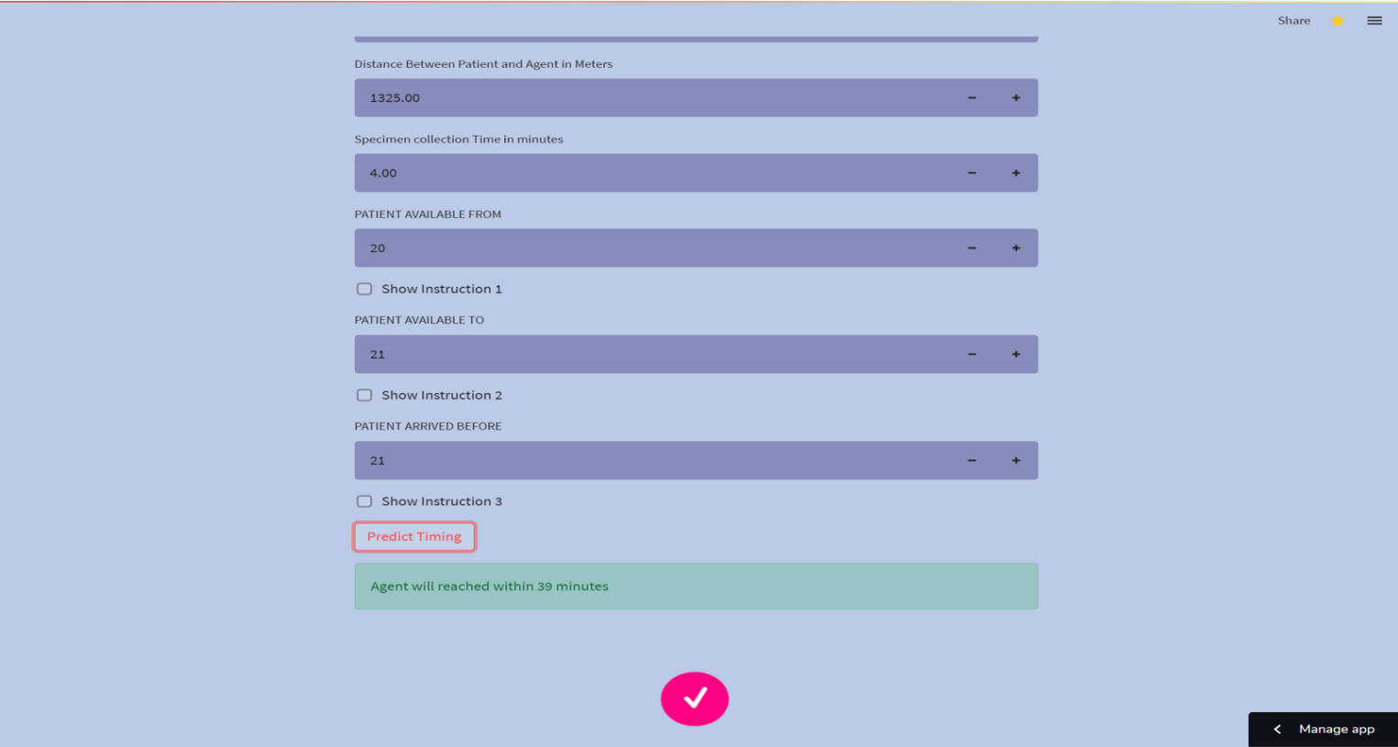

Image 3:-

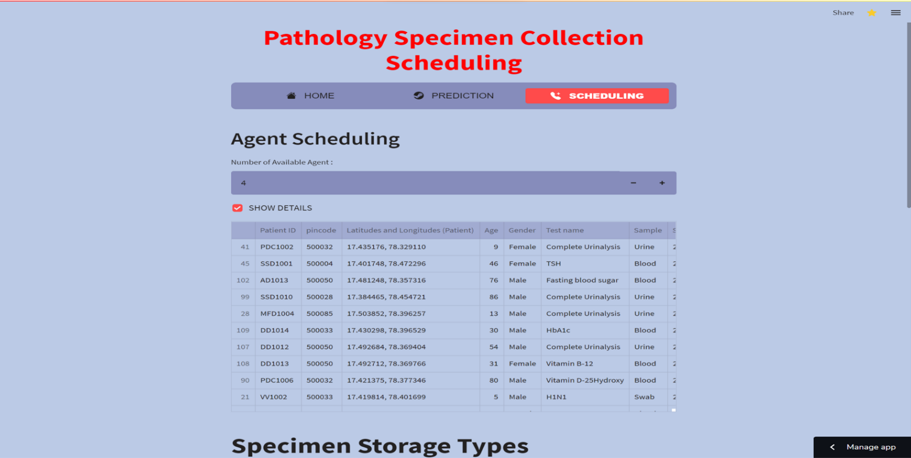

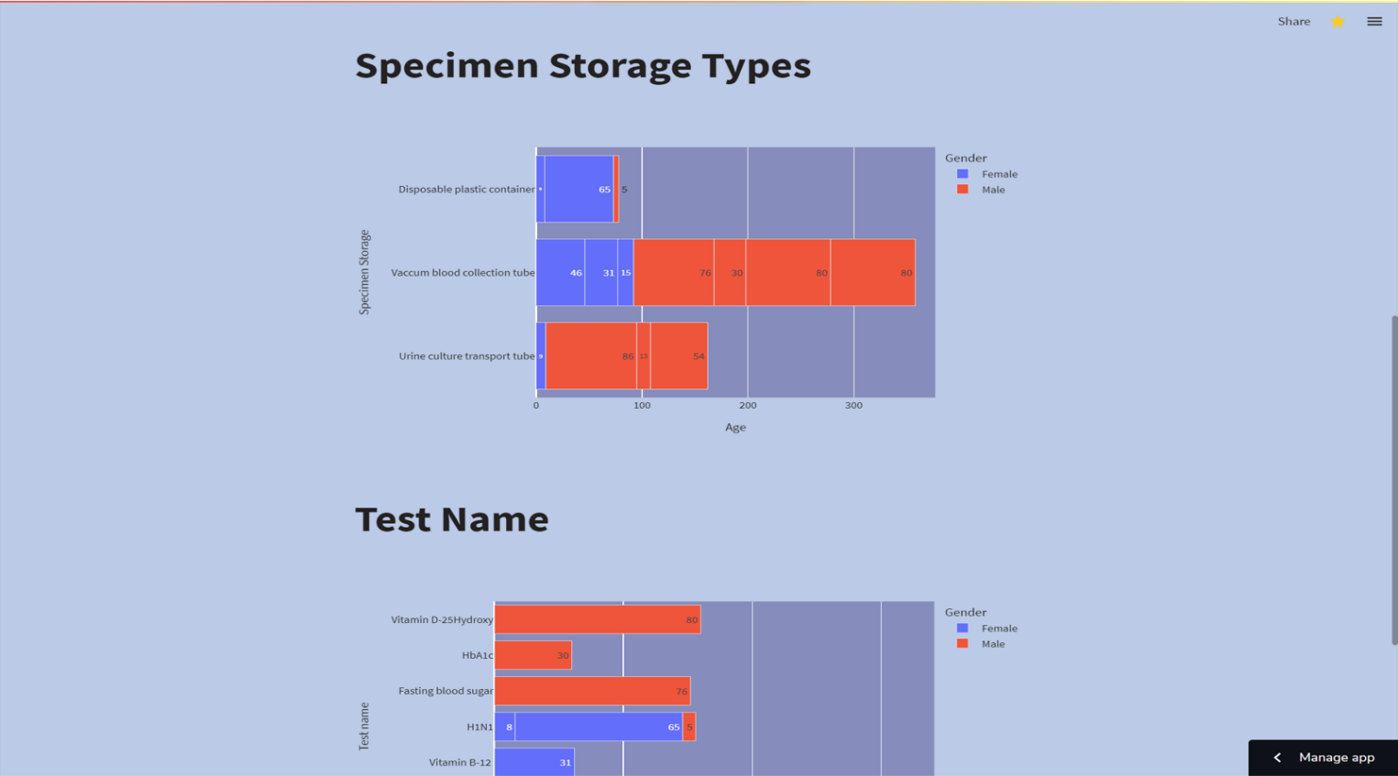

Image 4:- Image showing final Prediction/ Result of given input for User.



**THANK YOU**